This section includes instructions for completing both the standard and information-only Confidential Screening/Billing Report (PM 160) claim forms. For general information about these forms, refer to the Confidential Screening/Billing Report (PM 160) Claim Form section in this manual.

Standard PM 160 See Figure 1 on a following page for a sample of a standard
Claim Form Confidential Screening/Billing Report (PM 160).

Information-Only PM 160 See Figure 2 on a following page for a sample information-only
Claim Form Confidential Screening/Billing Report (PM 160 Information Only).

Laboratories: Claim Clinical laboratories use the Confidential Screening/Billing Report
Completion Instructions (PM 160) Claim Form: Completion Instructions for Labs section in this manual for claim completion instructions.

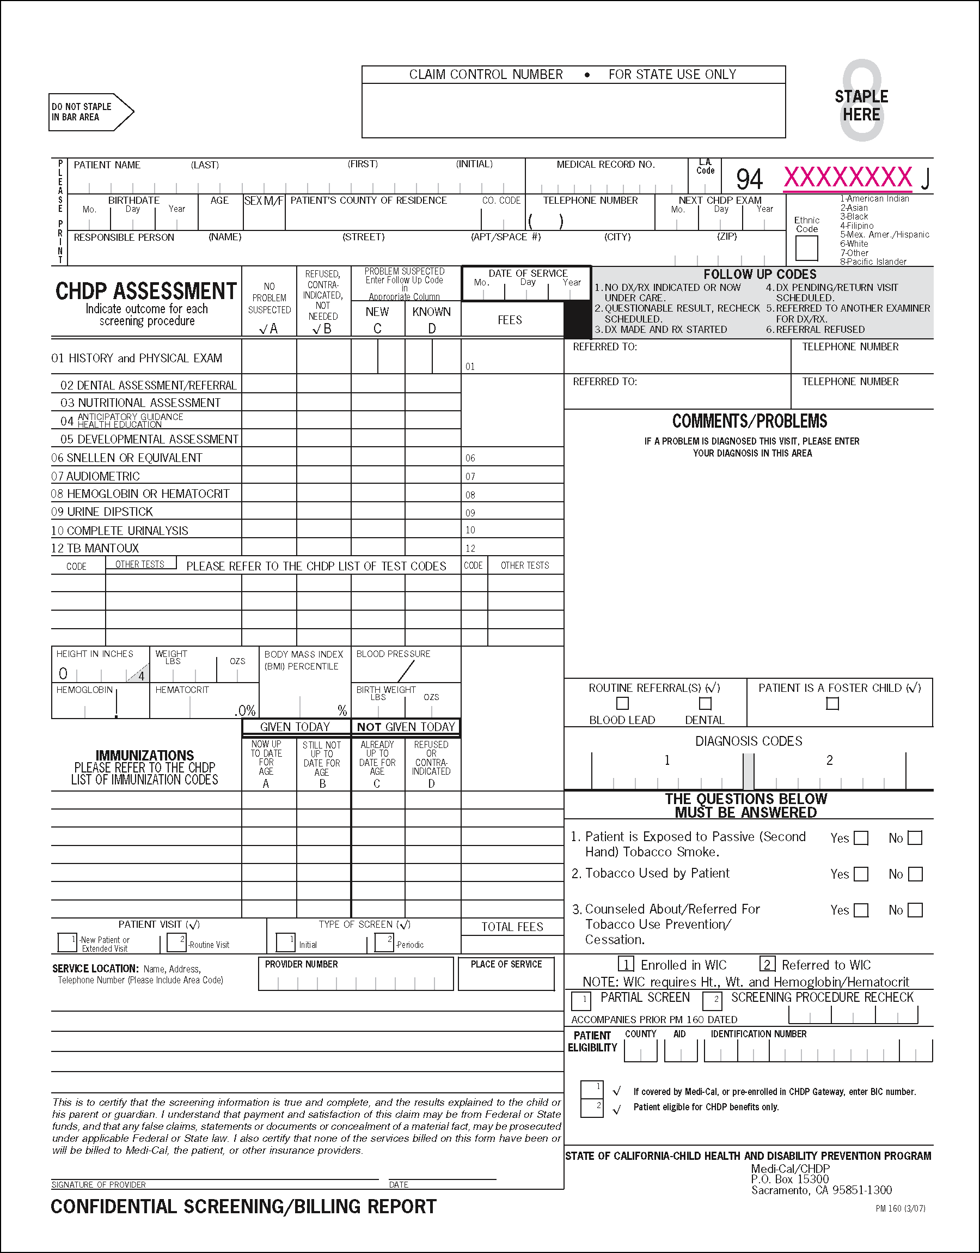

Figure 1. Confidential Screening/Billing Report (PM 160, Revised 3/07).
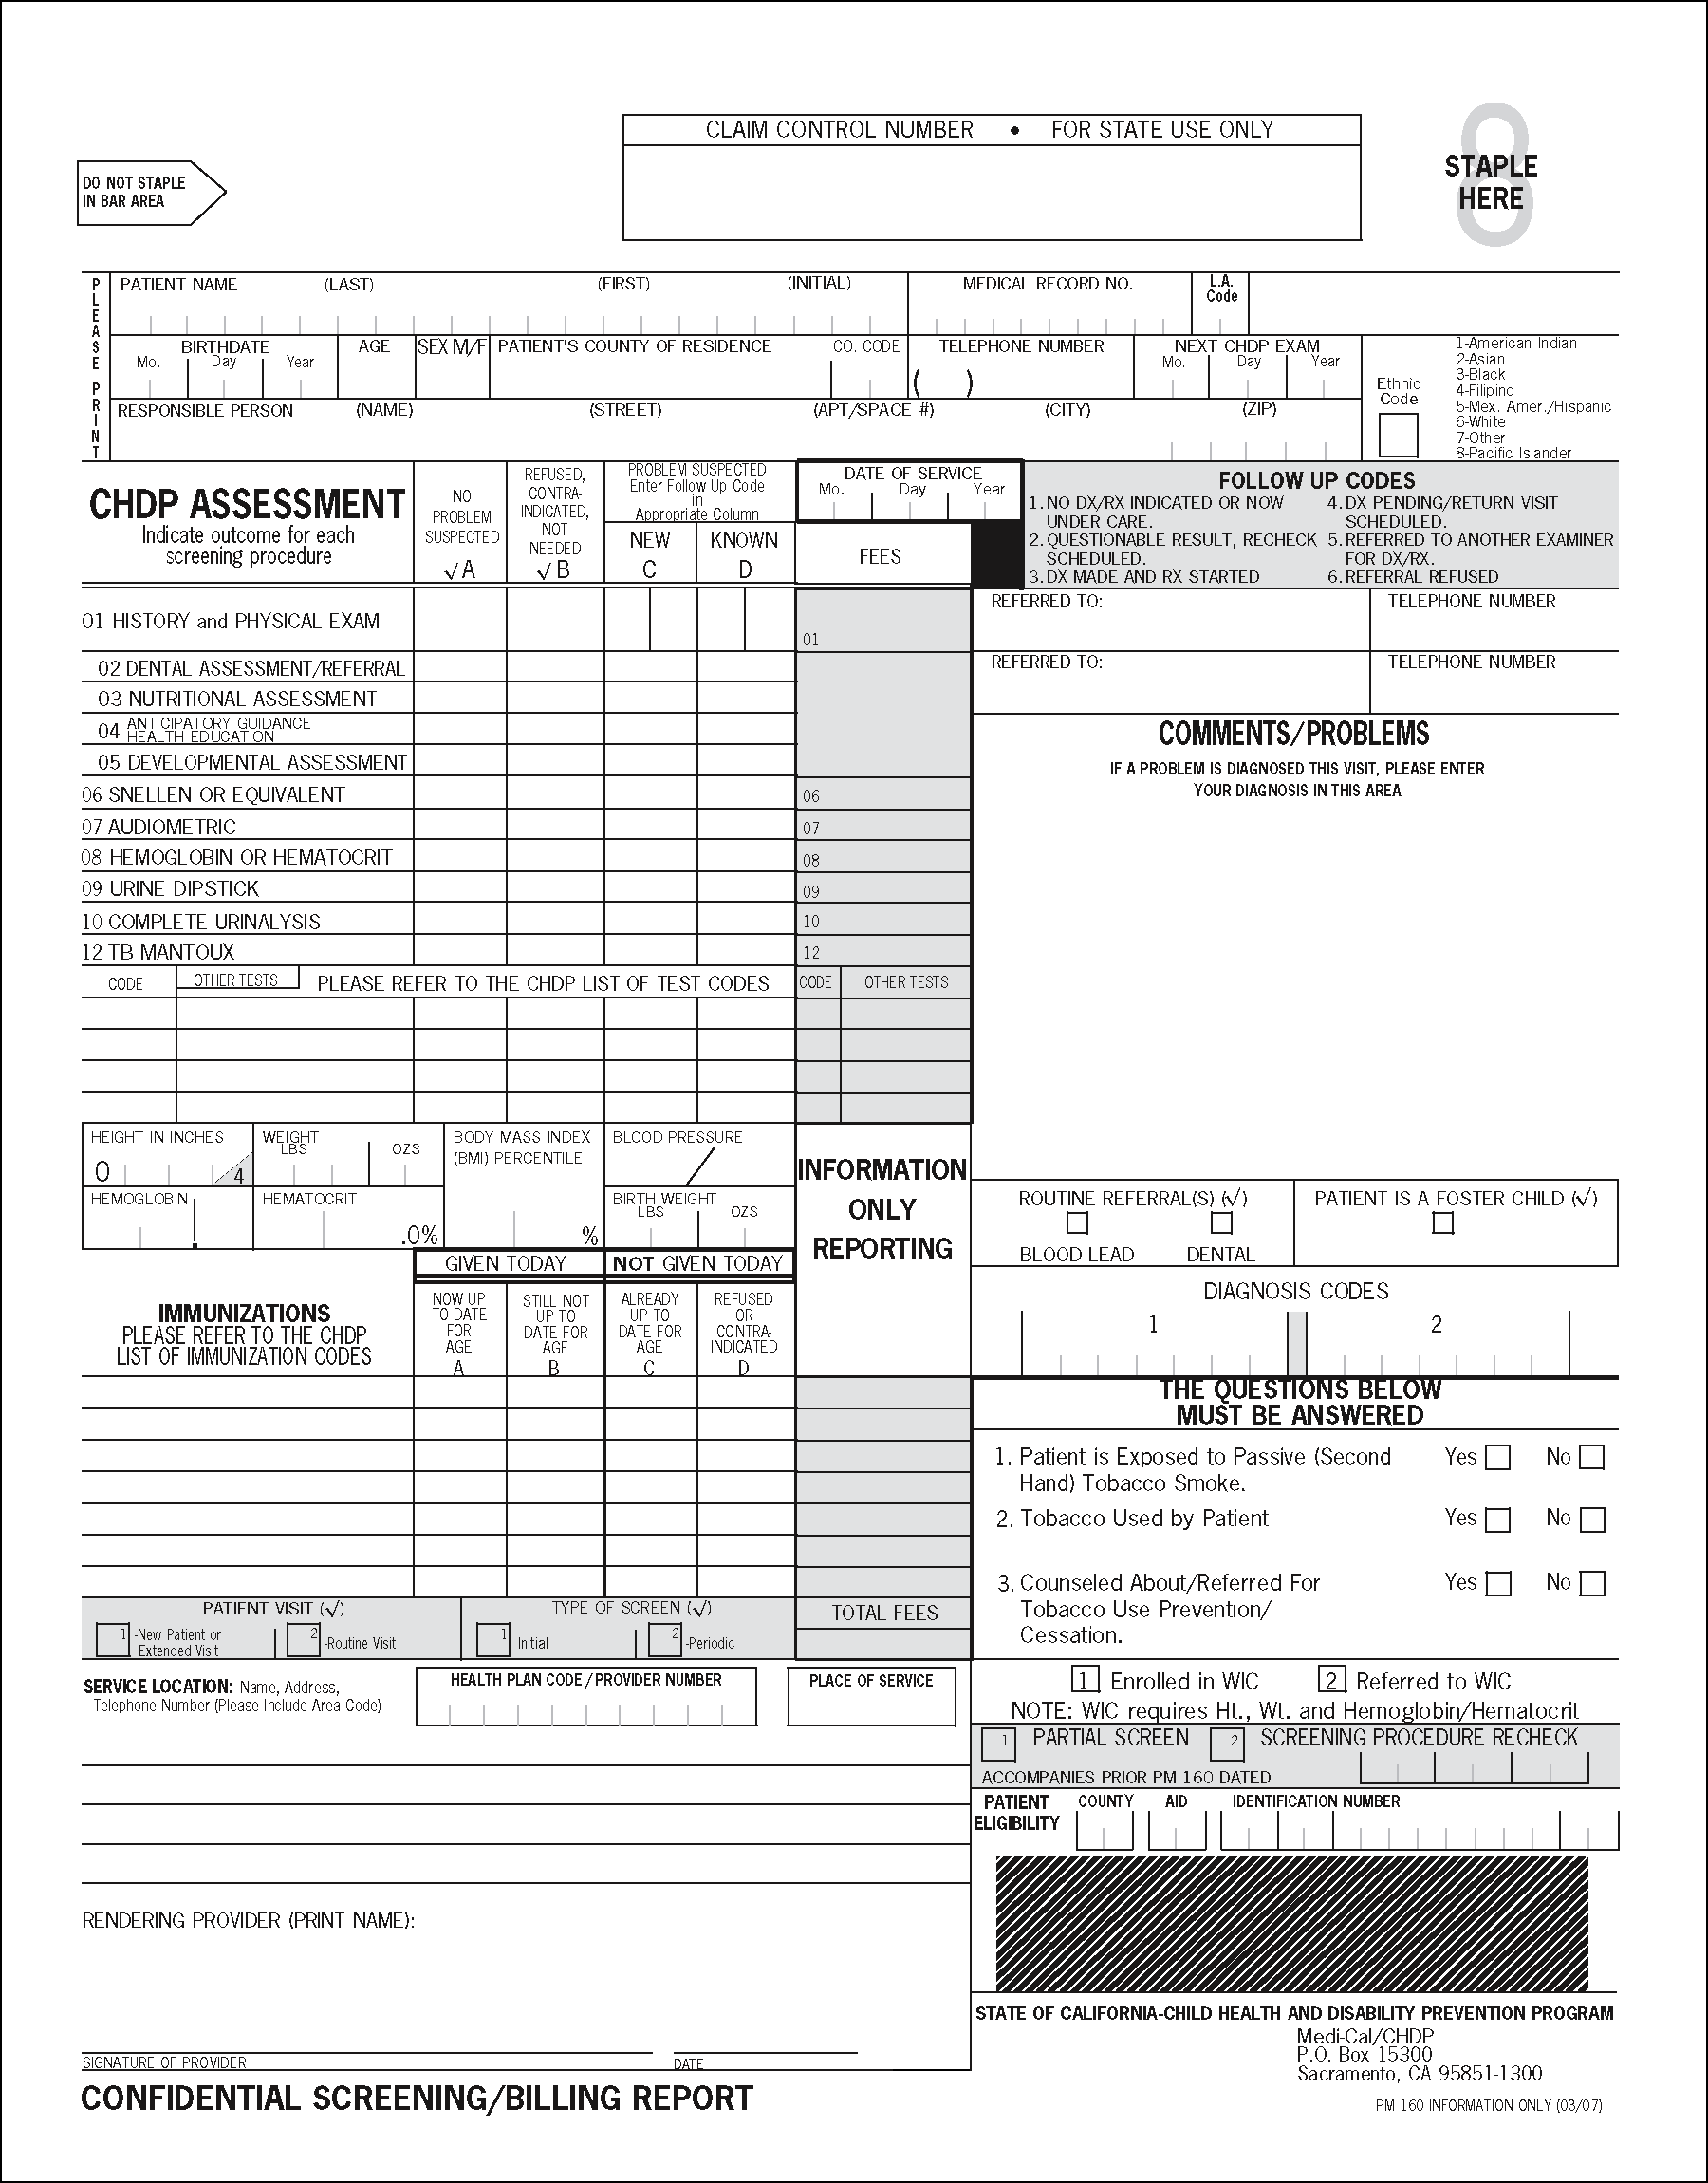

Figure 2. Confidential Screening/Billing Report (PM 160 Information Only, Revised 3/07).
Explanation of The following descriptions and instructions apply to both the standard
Form Items and information-only Confidential Screening/Billing Report (PM 160) claim forms, except as noted. Sample PM 160s also appear in the Appendix of this manual.

Patient Information PATIENT NAME. Enter the patient’s last name, first name and middle initial, exactly as it appears on the Benefits Identification Card (BIC), including blank spaces. If the patient’s name differs in any way from the name on the BIC or is incorrect, enter the name that the patient is Also Known As (AKA) in the name block or in the Comments/ Problems area.

MEDICAL RECORD NUMBER. (Optional) Use this space to enter the patient’s record or account number assigned by the provider.

Note: This number will appear on the CHDP Remittance Advice (RA).

L.A. Code. For Los Angeles County use only.

PRE-IMPRINTED FIELD. This field is pre-imprinted with a form
control number that begins with “94” and ends with either “J” or “K.”

BIRTH DATE. Enter the month, day and year of the patient’s birth exactly as it appears on the Medi-Cal eligibility verification system. Use zeros (0) when entering dates of only one digit (for example, January 1, 2003 is entered as 010103). If the birth date stated on the Medi-Cal eligibility verification system is incorrect, note the discrepancy in the Comments/Problems area.

AGE. Enter the patient’s age with one of the following indicators: “y” for years, “m” for months, “w” for weeks, or “d” for days (for example, 15y represents 15 years of age).

SEX. Enter an “F” if the patient is female. Enter an “M” if the patient is male. This must be entered exactly as it appears on the Medi-Cal eligibility verification system. If the sex stated on the Medi-Cal eligibility verification system is incorrect, note this in the Comments/ Problems area.

PATIENT’S COUNTY OF RESIDENCE AND CODE. Enter either the name and appropriate two-digit code of the county where the patient lives (not county where assessment is performed) or the two-digit city code if the individual lives in Berkeley, Long Beach or Pasadena.

Code | County | Code | County
1 | Alameda | 30 | Orange
2 | Alpine | 31 | Placer
3 | Amador | 32 | Plumas
4 | Butte | 33 | Riverside
5 | Calaveras | 34 | Sacramento
6 | Colusa | 35 | San Benito
7 | Contra Costa | 36 | San Bernardino
8 | Del Norte | 37 | San Diego
9 | El Dorado | 38 | San Francisco
10 | Fresno | 39 | San Joaquin
11 | Glenn | 40 | San Luis Obispo
12 | Humboldt | 41 | San Mateo
13 | Imperial | 42 | Santa Barbara
14 | Inyo | 43 | Santa Clara
15 | Kern | 44 | Santa Cruz
16 | Kings | 45 | Shasta
17 | Lake | 46 | Sierra
18 | Lassen | 47 | Siskiyou
19 | Los Angeles | 48 | Solano
20 | Madera | 49 | Sonoma
21 | Marin | 50 | Stanislaus
22 | Mariposa | 51 | Sutter
23 | Mendocino | 52 | Tehama
24 | Merced | 53 | Trinity
25 | Modoc | 54 | Tulare
26 | Mono | 55 | Tuolumne
27 | Monterey | 56 | Ventura
28 | Napa | 57 | Yolo
29 | Nevada | 58 | Yuba

Code | City | Code | City
59 | Berkeley | 63 | Pasadena
62 | Long Beach

TELEPHONE NUMBER. Enter residence, business or message telephone number, including area code where a responsible person can be reached during the day. This number is critical to enable local CHDP program staff to assist families in removing barriers to diagnosis and/or treatment.

NEXT CHDP EXAM. Enter the month, day and year that the next complete health assessment is due.

Use a leading zero (0) when entering dates of only one digit (for example, April 15, 2003 is entered as 041503). Enter the month and year of the next appointment for children 3 years of age and older.

RESPONSIBLE PERSON ADDRESS. When the patient is younger than 18 years of age and not an emancipated minor, enter the name, street address (including apartment or space number), city, and ZIP code of the parent, legal guardian or foster parent with whom the patient lives.

ETHNIC CODE. Enter the appropriate ethnic code (select one only). If the patient’s ethnicity is not included in the code list on the PM 160, or if ethnicity is unknown, enter code 7 (Other). See the Appendix in this manual for the Asian and Pacific Islander Groups Reported in the 1980 Census chart. The chart differentiates Pacific Islanders from other Asian groups.

Date of Service DATE OF SERVICE. Enter the date the CHDP service was rendered. Use a leading zero (0) when entering dates with only one digit (for example, March 1, 2003 is entered as 030103).

If procedures were performed on different days, enter the date of the History and Physical Exam.

Verify that the month and year of the “Date of Service” are the same as the month and year of eligibility for services.

CHDP Health Assessment CHDP ASSESSMENT. This section is used to record the screening
Screening Procedures procedures performed and outcomes of the procedures.
and Codes
Screening procedures appropriate to a patient’s age and sex are listed on the Periodicity Schedule for Health Assessment Requirements by Age Groups table in the Appendix of this manual. (See the CHDP Health Assessment Guidelines, CHDP provider information notices and CHDP bulletin updates for further test use criteria.) Screening procedure codes 01 through 12 are pre-printed on the form.

Code Screening Procedure

01 History and Physical Exam
02 Dental Assessment/Referral
03 Nutritional Assessment
04 Anticipatory Guidance Health Education
05 Developmental Assessment
06 Snellen or Equivalent (visual acuity)
07 Audiometric
08 Hemoglobin or Hematocrit
09 Urine Dipstick
10 Complete Urinalysis
12 TB Mantoux

See also “Other Tests” on a following page in this section to bill for screening procedure codes that are not pre-printed on the form.

Assessment Outcome COLUMNS A THRU D. Every screening procedure must have either
Columns a check mark () in column A or B or a numeric follow-up code in column C and/or D.

          - Do not enter check marks () in both columns A and B for the same procedure.

          - Do not enter check marks () in columns C and D.

          - Do not enter a check mark () in column A or B and also enter a follow-up code in column C and/or D for the same procedure.

          - A follow-up code may be entered in both columns C and D for a single screening procedure if that procedure reveals both a new problem and the recurrence of an old problem.

          - For Screening Procedure 01, “History and Physical Exam,” up to two follow-up codes may be entered in column C and up to two follow-up codes may be entered in column D.

          - Fees entered will not be reimbursed when column B is checked.

          - Outcomes and comments should always be entered by the examiner.

          - Entries are made in the assessment outcome columns for procedures 01 through 12 and for “Other Tests.”

Column A (No Problem COLUMN A. No Problem Suspected. Enter a check mark () in
Suspected) this column if the procedure is performed and no problem is
suspected, or if a child 1 year of age or older is being referred to a
dentist for routine dental care.
Column B (Refused, COLUMN B. Refused, Contraindicated, Not Needed. Enter a
Contraindicated, Not Needed) check mark () in this column when the procedure is one of the following:

Refused. The patient or responsible person refuses the procedure for any reason, or the patient is unable to cooperate in a procedure where the provider attempts to obtain a specimen or perform a procedure. It is also considered a refusal of a test when the patient or family does not call back or return for a reading of a tuberculin test.

Contraindicated. The procedure is deemed medically inappropriate.

Not Needed. The test is not appropriate for the patient’s age or the test was recently done.

Enter an explanation in the Comments/Problems area when a child does not receive a test appropriate for the child’s age according to the Periodicity Schedule for Health Assessment Requirements by Age Groups table. See this table in the Appendix of this manual.

Column B: Exclude Do not check column B when laboratory tests are performed outside
Checkmark of the provider’s office. Enter the results of the tests even though no fee is charged to CHDP.

Note: No reimbursement will be made for a procedure if outcome column B is checked. The only exception is a tuberculin test that has been given but the provider cannot obtain a reading.

Column C (New) and COLUMNS C AND D. Problem Suspected: Enter Follow-up Code
Column D (Known) in Appropriate Column. Determine if the condition or problem is one of the following:

New. Not known to the family per history and currently or previously not under care.

Known. Is known to the family per history and currently or previously under care.

Follow-up Codes FOLLOW-UP CODES. Do not use check marks () in column C
or D. Use only follow-up codes 1 – 6 as follows:

Code 1. NO DX/RX INDICATED OR NOW UNDER CARE.
Enter code 1 if no treatment is indicated or the patient is now under care (for example, dental problem now under care).

Code 2. QUESTIONABLE RESULT. RECHECK SCHEDULED.
Enter code 2 if the accuracy of a test result is questionable. Use
only for screening procedures 06 through 20 and 22. Codes 23 through 26 may be repeated as medically appropriate. A fee may
be charged for this screening procedure even though the result is questionable.

Code 3. DX MADE AND RX STARTED.
Enter code 3 if the diagnosis and treatment of a problem are started on this visit. Enter the diagnosis and the appropriate
ICD-9-CM diagnosis code in the Comments/Problems area.

Code 4. DX PENDING/RETURN VISIT SCHEDULED.

Enter code 4 if:

a. A return visit has been scheduled for diagnosis, or

b. A return visit has been scheduled for diagnosis and
treatment, or

c. A return visit has been scheduled for treatment only. Enter the diagnosis and the appropriate ICD-9-CM diagnosis code in the Comments/Problems area.

Code 5. REFERRED TO ANOTHER EXAMINER FOR DX/RX.

Enter code 5 if:

a. The patient has been referred to another provider for diagnosis and treatment. Enter the name and telephone number of the other provider in the designated area.

b. A diagnosis has been made on the day of the health assessment and the patient has been referred to another provider for treatment. Enter the diagnosis and the appropriate ICD-9-CM diagnosis code in the Comments/ Problems area. Enter the name and telephone number of the “Referred To” provider in the Referred To area.

c. A dental problem is suspected. Enter the name and telephone number of the dentist in the Referred To area.

Code 6. REFERRAL REFUSED.

Enter code 6 if the patient or the responsible person has refused referral or follow-up by examiner for any reason.

Other Tests OTHER TESTS—PLEASE REFER TO THE CHDP LIST OF TEST CODES. Screening procedure codes 13 through 24 are not
pre-printed and must be entered on the form. When one of these tests is performed, enter either a check mark () in outcome column A or an appropriate numeric follow-up code in outcome column C
and/or D. Do not enter a check mark () in the “Other Tests” outcome columns unless other tests are performed.

Up to three specimens, collected from three different sites for gonorrhea (GC) tests (code 17), may be billed on one line in the “Other Tests” area. Multiply the maximum amount reimbursed for one specimen by the number of sites tested. Indicate the number of site specimens billed in the Comments/Problems area.

Up to three specimens for ova/parasites (code 22) tests may be billed on one line in the “Other Tests” area. Multiply the maximum amount reimbursed by the number of specimens analyzed. Indicate the number of specimens billed in the Comments/Problems area.

Refer to “Laboratory Tests” in the Child Health and Disability Prevention (CHDP) Program: Billing and Reimbursement and “Laboratory Codes and Rates” in the Rates: Maximum Reimbursement for CHDP section of this manual for frequency and reimbursement information related to the following codes.

Code Screening Procedure

13 Sickle Cell: Electrophoresis

15 Lead: Blood lead

16 VDRL, RPR or ART

17 Gonorrhea (GC) Test

18 Pap Smear **

20 Chlamydia Test **

21 Pelvic examination

22 Ova and/or parasites

23 Lead test counseling and blood drawing for lead testing

24 Lead Refer – Counseling and referral for blood drawing for lead testing

25 Blood Glucose

26 Total Cholesterol

** Include an explanation in the Comments/Problems area if the child is younger than the age indicated in “Testing Guidelines” in the Child Health and Disability Prevention (CHDP) Program: Billing and Reimbursement section of this manual.

Vital Statistics HEIGHT IN INCHES, WEIGHT, BODY MASS INDEX (BMI), BLOOD PRESSURE, HEMOGLOBIN, HEMATOCRIT AND BIRTH WEIGHT. Fill in all spaces. Use zeros, as necessary. Use the American (pounds and inches) system for height and weight measurements.

Note: If an American and metric system indicator is included in the Medi-Cal provider software and/or Computer Media Claims system, enter an “x” in the box under the “A” for “American” measurement.

Height in Inches HEIGHT IN INCHES. If the child is younger than 25 months of age, measure the child’s recumbent (lying down) length. If the child is 25 months of age or older, measure the child’s standing height.

Record the height or length in inches to the nearest quarter inch. Fill in all spaces. A “0” is preprinted in the first (left) space. Enter whole inches in the second and third spaces. A “4” is preprinted in the last (right) space. Convert all fractions of an inch to fourths (1/4) and enter as follows:

Whole inches = Enter “0”
1/4 inch = Enter “1”
1/2 inch = 2/4 = Enter “2”
3/4 inch = Enter “3”

Weight WEIGHT. Enter weight in pounds and to the nearest ounce. Enter a leading zero in the first space for weights of less than 100 pounds.

Use the last two spaces for ounces. Enter zeros when there are no ounces.

Body Mass Index (BMI) Identify Body Mass Index (BMI) number based on height (inches) and
Percentile weight (pounds). Plot the BMI number on the “BMI-for-age percentile”
growth chart according to gender and age to obtain the BMI
percentile. See the Centers for Disease Control and Prevention
(CDC) BMI Growth Charts in the Appendix of this manual to determine
BMI percentile. Record the BMI percentile using whole numbers.

Record the BMI percentile on the PM 160 claim form by using two whole numbers, placing one number on each side of the separating line in the Body Mass Index (BMI) Percentile box. When the number is less than 10, place a zero to the left of the separating line and the single digit number to the right of the separating line. Do not use more or less than two digits or other symbols in this field, such as decimal points or less than signs (<). The highest number that can be used is 99.

Examples of correct recording of BMI percentile:
BMI
0 | 5 | Designates BMI Percentile at the 5th %
9 | 0 | Designates BMI Percentile at the 90th %
9 | 9 | Designates BMI Percentile at and/or over the 99th %

Examples of incorrect recording of BMI percentile:
BMI
27 | 9 | Incorrect – there are more than 2 digits
<8 | 5 | Incorrect – less than symbol (<) is used
100 | 0 | Incorrect – there are more than 2 digits
.5 | 0 | Incorrect – decimal is used
9 |  | Incorrect – there is only one digit

For more information, refer to the “Body Mass Index (BMI)-for-Age Percentile” Provider Information Notice (PIN) at www.dhcs.ca.gov/services/chdp/Documents/Letters/
chdppin0802.pdf

Blood Pressure BLOOD PRESSURE. Record both the systolic and diastolic blood pressure for children 3 years of age and older.

Hemoglobin HEMOGLOBIN. Record amounts to the nearest 0.1 gram. Always enter three digits so that every box is filled. Add leading zeros when needed. Do not leave a box empty.

Example: A hemoglobin level of 8.5 grams is recorded as 08.5.

Hematocrit HEMATOCRIT. Record numbers to the nearest whole number. Do not enter more than two digits, only whole numbers.

Do not enter tenths, such as 34.1 percent.

Do not enter % marks.

Example: 34.1%-34.4% would be entered as 34 and 34.5%-34.9% would be entered as 35.

Birth Weight BIRTH WEIGHT. Enter the birth weight, if known, in pounds and ounces. Birth weight should be entered for children younger than 2 years of age.
Use the same system for recording birth weight that was used for recording height or weight.

If a parent reports the child’s birth weight in kilograms, convert the amount to pounds and ounces by multiplying the birth weight by 2.2 and converting the fraction of pounds to ounces.

Example: Conversion formula: Kilograms (kg) x 2.2 = Pounds. Multiply the remaining decimal by 16 to obtain ounces and round to nearest whole number. Therefore, 3295 grams or 3.3 kilograms x 2.2 = 7.26 pounds and 26 pounds x 16 = 4.16 ounces (rounded to 4 ounces).

Immunizations IMMUNIZATIONS. When billing for immunizations, enter the code for the immunization and the name of the vaccine on a blank line in the Immunizations area.

Enter a check mark () in either column A or B for each immunization and enter the appropriate fee.

Note: Fees do not apply to the PM 160 Information Only claim form.

Determine if an immunization is to be “Given Today” or “Not Given Today.”

If an immunization is given today, enter a check mark () as follows:

        - Column A. (Now Up to Date for Age). This indicates that the immunization given today brings the patient up-to-date for their age.

        - Column B. (Still Not Up to Date for Age). This indicates the immunization given today does not bring the patient up-to-date for their age.

If an immunization is not given today and you wish to record immunizations for which the child was assessed but not given at the time of the health assessment, enter a check mark () as follows:

        - Column C. (Already Up to Date for Age). The immunization status is current or the patient has had the disease.

        - Column D. (Refused or Contraindicated). The patient or responsible person refuses the needed immunization, the administration of a needed dose is medically contraindicated or is deemed inappropriate.
Do not enter fees when recording immunizations in column
C or D.

If immunizations are administered, complete the entire Immunizations area.

Patient Visit: PATIENT VISIT. These instructions apply to the standard PM 160
Standard PM 160 (not to the PM 160 Information Only) claim form.

The time spent with the patient is the determining factor in claiming an extended visit or a routine visit, as follows:

New Patient or Extended Visit

New Patient: Enter a check mark () if the patient has not previously received a CHDP health assessment by this provider and no CHDP health assessment record is established with this provider.

Extended Visit: Enter a check mark () if the patient requires as much or more time to be assessed as does a new patient.

Note: When claiming for an extended visit for patients assessed within the last two years, indicate the reason in the Comments/Problems area.

Routine Visit: Enter a check mark () if the patient’s visit is a routine return visit and the visit requires less time than ordinarily needed with a new patient or for an extended visit.

Type of Screen: TYPE OF SCREEN. These instructions apply to the standard PM 160
Standard PM 160 (not to the PM 160 Information Only) claim form.

Initial: Enter a check mark () if this is, to the best of your knowledge, the first time that the patient has received a CHDP health assessment and tests by any provider.

Periodic: Enter a check mark () if the patient has previously received a CHDP health assessment and tests by any provider.

Fees: FEES. These instructions apply to the standard PM 160 (not to the
Standard PM 160 PM 160 Information Only) claim form.

Providers are encouraged to bill at their usual and customary charges. Reimbursement for all CHDP services will be either at the provider’s usual and customary charges or the amount specified in the CHDP Schedule of Maximum Allowances, whichever is less. Refer to the Rates: Maximum Reimbursement for CHDP section in this manual.

Be sure that a fee is entered on the line that matches the screening procedure and/or immunization codes being billed.

Fees for “Other Tests” must include the procedure code and the appropriate fee in the fee column.

Fees for immunizations must include the appropriate code with the appropriate fee in the fee column.

Total Fees: TOTAL FEES. Add fees and enter the total amount.
Standard PM 160

Service Location Service Location. Enter the following information on the appropriate line:

Line 1: Business name
Line 2: Street address
Line 3: City, state and nine-digit ZIP code
Line 4: Telephone number, including area code

Provider Number for Provider Number. When billing for services rendered, enter your
Standard PM 160 provider number in spaces beginning to the left. The provider number
must be accurate and legible as claims are automatically paid to the provider number listed on the PM 160.

Provider Number for Health Plan Code Number. This code is assigned to Medi-Cal
PM 160 Information Only health care plans and is used only on the PM 160 Information Only claim form. Enter the three-digit health plan code number in the first (left) three spaces of the field.

Note: Federally Qualified Health Centers (FQHCs), Rural Health
Clinics (RHCs) and Tribal Health Clinics (THCs) enter a provider number, instead of a health plan code number, on the PM 160 Information Only claim form.

Place of Service PLACE OF SERVICE. Enter the two-digit Place of Service code that best describes where the service was rendered:

Place of Service
Code Description

11 Office (any location other than Place of Service code 22 or 71)
22 Outpatient Hospital
71 State or Local Public Health Clinic
72 Rural Health Clinic
81 Independent Laboratory
99 Other

Signature of Provider SIGNATURE OF PROVIDER. You or a designated representative must sign and date the PM 160 or PM 160 Information Only claim form. Do not use a signature stamp.

Referrals to Other REFERRED TO and TELEPHONE NUMBER. When referrals are
Providers made to other providers, enter the name and telephone number of the other provider or agency (when this information is available).

If the patient is referred to more than two providers, enter the additional provider name or agency and telephone number in the Comments/Problems area.

Comments or Problems COMMENTS/PROBLEMS. Use this space for remarks that clarify the results of the health assessment and communicate issues to the local and State CHDP programs.

Following are examples of information to include when appropriate:

        - The reason(s) for performing Medically Necessary Interperiodic Health Assessments (MNIHAs).

Required in this field: A comment explaining the reason that a MNIHA service was performed, even if the need for a MNIHA
was identified at the time of the Gateway transaction.

        - Diagnosis and related IDC-9 code, if a diagnosis is made during the visit.

        - Explanation of suspected problems; for example, the nature of a dental problem. Identify dental problems using the “Classification of Dental Treatment Needs,” Classes II–IV. See the American Dental Association’s “Classification of Treatment Needs” in the Appendix of this manual.

        - Identify whether a patient 3 years of age or older is receiving (or the last time received) dental care.

        - Explain when a procedure is not performed when the procedure is listed as recommended for age. (See the Periodicity Schedule for Health Assessment Requirements by Age Groups table in the Appendix of this manual). This includes tests that are performed at an age younger than the age specified.

        - Record the screening procedure code and the name and telephone number of the referred provider when more than two referrals are made.

        - Document the head circumference measurement for children 2 years of age or younger. Record measurements to one-fourth (1/4) inch.

        - Results of vision test.

        - Results of blood lead tests, when known.

        - Primary language of the patient or guardian if other than English.

        - Patient did not return for the reading of a Tuberculin (TB) test.

        - Note discrepancies between known information and information provided by the eligibility verification system; for example, gender.

        - Mother’s Medi-Cal identification number is being used to bill for services rendered to an infant during the birth month or the month following.

        - The reason for extra time spent with the patient when billing for an “Extended Visit” for other than new patients or patients not assessed within the last two years.

        - Immunization administered because individual is in a high-risk category.

        - Elevated blood lead levels.

        - Results of blood glucose test and whether the results are within normal limits.

        - Results of cholesterol test and whether the results are within normal limits.

Routine Referrals ROUTINE REFERRALS.

BLOOD LEAD. Enter a check mark () in this box when a child has been referred to a laboratory for the collection of a blood specimen for the lead test.

DENTAL. Enter a check mark () in this box only when no dental problem is suspected, but you have advised the parents to obtain the annual preventive dental care for a Medi-Cal child. Annual referrals begin at age 3 or earlier, if necessary, for maintenance of dental health.

Foster Child Indicator PATIENT IS A FOSTER CHILD. Enter a check mark () when the patient is in a foster care home or has been placed with a relative by the county welfare department.

Diagnosis Codes DIAGNOSIS CODES. Enter the International Classification of Diseases code in the Diagnosis Codes area for each condition or problem suspected. Do not leave blank spaces in the boxes.

If the diagnosis code is fewer than five numbers, enter zeros in the
last (right) spaces of the box. For example, ICD-9-CM code 034 (strep throat) is entered as 03400 and ICD-9-CM code 493.9 (asthma, unspecified) is entered as 49390.

Tobacco Prevention/ THE QUESTIONS BELOW MUST BE ANSWERED. Enter patient’s
Cessation Questions response to the questions concerning smoking. (Refer to the CHDP Health Assessment Guidelines for “Protocol for Anti-Tobacco Health Education”).

1. Patient is exposed to passive (second-hand) tobacco smoke?

2. Tobacco used by patient?

3. Patient counseled about/referred for tobacco use prevention/cessation?

WIC Status ENROLLED IN WIC. Infants and children younger than 5 years of age, pregnant women at nutritional or medical risk, and women up to six months postpartum or breastfeeding an infant younger than 12 months of age may be eligible for the Women, Infants, and Children (WIC) Supplemental Nutrition Program.

If the patient is already enrolled in WIC, enter an “X” in Enrolled in WIC (Box 1).

If you are making a referral to the WIC Program, enter an “X” in Referred to WIC (Box 2).

WIC requires that height, weight, hemoglobin and hematocrit values be entered.
.
Note: Specify in the Comments/Problems area whether you are requesting CHDP staff assistance to refer a family to WIC.

Call your local CHDP program to receive information about the WIC program.

Partial Screens PARTIAL SCREEN. Complete the partial screening procedure and enter the information on the PM 160 as follows:

- Enter the patient and provider identifying information

- Enter a check mark () in Column A or a numeric follow-up code in Column C or D for the procedure given

- Enter the appropriate remarks, such as justification of the partial screen, tests, etc., in the Comments/Problems area

- If immunization services were rendered, enter the code number of the immunization, and complete Column A or B

- Enter the date of service

- Enter a check mark () in the Partial Screen box

- Enter the date of the complete CHDP health assessment from the prior PM 160 or the future date of the CHDP health assessment in the Accompanies Prior PM 160 Dated area

- Enter the “Patient Eligibility” information

- Enter “Fee(s)”

- Enter “Total Fees”

For general information about partial screens, refer to “Partial Screens” in the Child Health and Disability Prevention (CHDP) Program: Billing and Reimbursement section of this manual.
Recheck of SCREENING PROCEDURE RECHECK. Complete the screening
Screening Procedure procedure recheck and enter the information as follows:

- Enter patient and provider identifying information

- Enter a check mark () in column A, or a numeric follow-up code in column C or D for the outcome of the screening procedure(s) being performed

- Enter appropriate remarks, such as justification for screening procedure recheck, test results, etc., in the Comments/ Problems area

- Enter a check mark () in the Screening Procedure Recheck box

- Enter the date of service

- Enter the date of service from the prior PM 160 in the in the Accompanies Prior PM 160 Dated area

- Enter the “Patient Eligibility” information

- Enter “Fee(s)”

- Enter “Total Fees”

Note: Only screening procedures 06 through 20 and 22 may be submitted for reimbursement as rechecks.

For general information about rechecks, refer to “Recheck of Screening Procedure” in the Child Health and Disability Prevention (CHDP) Program: Billing and Reimbursement section of this manual.

ACCOMPANIES PRIOR PM 160 DATED. Enter the date of the complete CHDP health assessment from the prior PM 160 or the future date of the health exam appointment in the Accompanies Prior PM 160 Dated area.

Patient Eligibility: PATIENT ELIGIBILITY (STANDARD PM 160). Patient eligibility
Standard PM 160 information on the standard PM 160 is completed as follows:

- COUNTY. Enter patient’s two-digit county code (obtained when eligibility verification is performed).

- AID. Enter patient’s two-digit aid code (obtained when eligibility verification is performed).

- IDENTIFICATION NUMBER. Enter patient’s identification number from the plastic Benefits Identification Card (BIC) or
Immediate Need Eligibility Document.

- If the patient is covered () by Medi-Cal or is pre-enrolled in Medi-Cal through the CHDP Gateway, enter a BIC number as above. Ensure that a check mark () appears in box 1.

Mother’s Medi-Cal A mother’s Medi-Cal identification number may be used to
Identification Number bill for services provided to an infant during the infant’s month of birth and the month immediately following.

Patient Eligibility: PATIENT ELIGIBILITY (PM 160 INFORMATION ONLY). Patient
PM 160 Information-Only eligibility information on the PM 160 Information Only claim form is completed the same as for the standard PM 160, except there are no separate boxes to check.

